Can’t log in to Clever?
Often times it is your internet browsers cache that is causing the problem.
Clearing the cache may be all you need to do. Here’s how for Chrome:
Click the 3 vertical dots in the upper right hand corner of Chrome.

From the resulting menu, click on “Settings”
To the left in the Settings screen, click on “Privacy and Security”
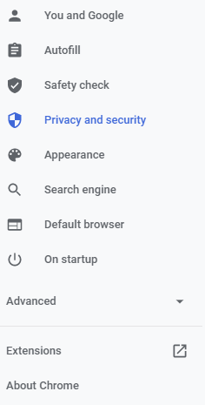

In the resulting window, click on “Clear browsing data”
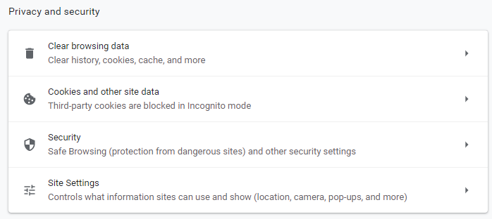

In the resulting pop-up window, make certain the “Passwords and other sign in data” is NOT selected, then click first on “Advanced” then on “Clear data”
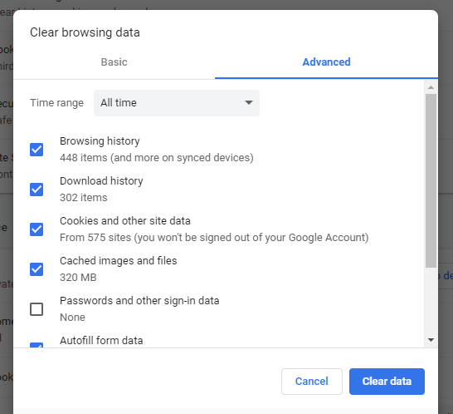

Close and reopen Chrome and try logging in to Clever.
If you still cannot get in, reboot your computer and try logging in again.
If you still cannot get in after a reboot, please send another email letting us know that this process did not work for you.

Thank you.

